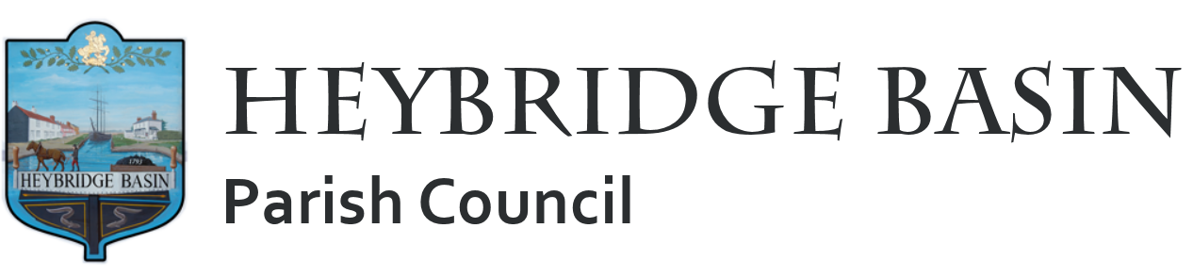

PUBLIC NOTICE
VACANCY FOR PARISH COUNCILLOR

Would you like to make a difference in your community?

Heybridge Basin Parish Council has a vacancy for a Parish Councillor, and we are seeking an engaged and community-minded individual to join us. This is an exciting opportunity to have a say in local matters and contribute to improving life in the parish.

The Returning Officer at Maldon District Council has confirmed that the Regulation 10 requests from electors have not been fulfilled. As a result, the Parish Council is now able to fill this casual vacancy by co-option.

Eligibility Criteria

To be eligible for co-option you must:

- Be a British Citizen, a Citizen of the Commonwealth or a Citizen of the European Union.
- Be aged 18 or over on the day of co-option.
- Not be subject to a bankruptcy restriction order or interim order.
- Not have been convicted in the UK within the last five years and received a prison sentence of over three months (whether suspended or not) without the option of a fine.

You must also meet at least ONE of the following:

- Be registered as a local government elector for the parish
- Have occupied as owner or tenant any land or premises in the parish for the past 12 months.
- Have had your principal or only place of work in the parish for the past 12 months.
- Have lived in the parish or within 3 miles of it for the past 12 months.

Why Join the Parish Council?

- Represent the views of local residents.
- Make a positive impact on your community.
- Help shape the future of the village

How to apply: Contact the Clerk to request an application form and confirm your eligibility.
Deadline to apply: Wednesday 30th April 2025

